CYBERSECURITY THREAT PREDICTION USING MACHINE LEARNING
University of New Haven
INFS_6610_01_Capstone_Project
Date: 05/01/2025

Author:
Mittapally Chaturya

ABSTRACT
In the rapidly evolving digital landscape, the frequency and sophistication of cyberattacks have significantly increased, posing critical risks to organizations, governments, and individuals. Traditional rule-based cybersecurity systems are often ineffective at identifying novel or advanced threats due to their reliance on static detection rules. As cybercriminals adapt and evolve, there is a pressing need for more intelligent, proactive security mechanisms.
This project investigates the application of machine learning (ML) algorithms for cybersecurity threat prediction, aiming to enhance the speed and accuracy of attack detection by learning from historical network traffic data. Utilizing the CICIDS2017 dataset, which includes a variety of labeled attack types such as DDoS, PortScan, and brute-force attempts, we implement and evaluate supervised learning models—specifically Logistic Regression and Naive Bayes—due to their interpretability, simplicity, and successful track record in prior research.
Our methodology involves merging and preprocessing selected portions of the CICIDS2017 dataset, handling missing values, transforming categorical variables, and performing exploratory data analysis (EDA) to uncover patterns indicative of malicious activity. Both Logistic Regression and Naive Bayes classifiers are trained on the processed data and evaluated using performance metrics such as accuracy, precision, recall, and F1-score.
Preliminary results show promising predictive capabilities for both models, particularly in distinguishing between benign and attack traffic while maintaining relatively low false positive rates. These findings reinforce the viability of ML-based threat detection systems and suggest that even lightweight models like Logistic Regression and Naive Bayes can significantly enhance an organization’s security posture. The prototype developed in this study serves as a foundational step toward building scalable and intelligent cybersecurity frameworks that can adapt to emerging threats.
Keywords: Cybersecurity, Intrusion Detection System (IDS), Threat Prediction, Machine Learning, Predictive Analytics, Supervised Learning, CICIDS2017 Dataset, Network Traffic Analysis, Logistic Regression, Naive Bayes, Decision Trees, Random Forest, Feature Engineering, Feature Selection, Data Preprocessing, Exploratory Data Analysis (EDA), Python Programming, Google Colab, Power BI Dashboard, Cross-Validation, Confusion Matrix, ROC-AUC, Model Interpretability, One-Hot Encoding, Outlier Capping, Z-score Normalization, Binary Classification, Lightweight Models, Scalable Frameworks, Real-Time Detection

Table of Content
Abstract----------------------------------------------------------------------------------------------1
Chapter 1: Introduction----------------------------------------------------------------------------6
1.1 The Growing Importance of Cybersecurity---------------------------------------6
1.2 Machine Learning in Threat Prediction--------------------------------------------7
1.3 Problem Statement--------------------------------------------------------------------8
1.4 Project Objectives---------------------------------------------------------------------10
Chapter 2: LITERATURE REVIEW------------------------------------------------------------11
2.1 The Need for Advanced Cybersecurity Solutions--------------------------------11
2.2 Machine Learning in Intrusion Detection Systems-------------------------------12
2.3 Machine Learning Models-----------------------------------------------------------13
2.3.1 Logistic Regression (LR) ------------------------------------------------13
2.3.2 Naive Bayes (NB) ---------------------------------------------------------14
2.3.3 Decision Trees (DT) ------------------------------------------------------15
2.4 Comparative Findings in Previous Research--------------------------------------17
2.5 Gaps in Literature and Motivation for This Study--------------------------------18
Chapter 3: DATASET DESCRIPTION---------------------------------------------------------19
3.1 Overview of the CICIDS2017 Dataset---------------------------------------------19
3.2 Data Collection Environment-------------------------------------------------------20
3.3 Dataset Composition-----------------------------------------------------------------20
3.4 Feature Set-----------------------------------------------------------------------------21
3.5 Attack Types Represented-----------------------------------------------------------22
3.6 Advantages of CICIDS2017---------------------------------------------------------23
3.7 Limitations and Considerations-----------------------------------------------------23
Chapter 4: METHODOLOGY-------------------------------------------------------------------24
4.1 Data Collection-----------------------------------------------------------------------24
4.2 Data Preprocessing-------------------------------------------------------------------25
4.3 Exploratory Data Analysis (EDA)-------------------------------------------------27
4.4 Feature Selection---------------------------------------------------------------------27
4.5 Model Development-----------------------------------------------------------------28
4.6 Model Evaluation--------------------------------------------------------------------30
4.7 Training and Testing Process------------------------------------------------------31
4.7.1 Data Partitioning----------------------------------------------------------31
4.7.2 Target Variable Selection------------------------------------------------32
4.7.3 Feature Preprocessing and Scaling-------------------------------------32
4.7.4 Feature Engineering and Selection-------------------------------------32
4.7.5 Model Training------------------------------------------------------------32 4.7.6 Model Evaluation Strategy-----------------------------------------------33
4.7.7 Summary-------------------------------------------------------------------33
Chapter 5: Model Evaluation and Results------------------------------------------------------34
5.1 ROC Curve Comparison------------------------------------------------------------34
5.2 Confusion Matrices------------------------------------------------------------------35
5.3 ROC Curves Per Model-------------------------------------------------------------38
5.4 Performance Summary Table------------------------------------------------------40
Chapter 6: IMPLEMENTATION--------------------------------------------------------------40
6.1 Tools and Development Environment---------------------------------------------40
6.2 Dataset Handling and Merging-----------------------------------------------------41
6.3 Data Cleaning and Preprocessing--------------------------------------------------41
6.3.1 Missing Value Handling-------------------------------------------------41
6.3.2 Outlier Detection and Capping------------------------------------------41
6.3.3 Feature Normalization----------------------------------------------------42
6.4 Exploratory Data Analysis (EDA) -------------------------------------------------42
6.5 Feature Engineering and Selection-------------------------------------------------42
6.6 Model Training Process-------------------------------------------------------------42
6.7 Evaluation Metrics and Visualization---------------------------------------------43
6.8 Summary of Implementation Insights---------------------------------------------43
Visual Insights--------------------------------------------------------------------------------------44
Real-World Relevance----------------------------------------------------------------------------- 44
7. Conclusion--------------------------------------------------------------------------------------45
References-------------------------------------------------------------------------------------------47
Appendix A: Data Dictionary---------------------------------------------------------------------48
Appendix B: Source Code-------------------------------------------------------------------------49
Appendix C: Power BI-----------------------------------------------------------------------------55

List of Figures
Fig 1 Network-Based Intrusion Detection System (NIDS) Workflow----------------------7
Fig 2 Real-World Layout of a Network-Based IDS-------------------------------------------9
Fig 3 Project Objective — ML-Based Classification of Network Threats------------------11
Fig 4 Block diagram of proposed methodology------------------------------------------------24
Fig 5 Feature Correlation Matrix displaying pairwise relationships between numeric attributes in the CICIDS2017 dataset---------------------------------------------------------------------------26
Fig 6 ROC Curve Comparison between Logistic Regression, Naive Bayes, and Decision Tree-34
Fig 7 Logistic Regression Confusion Matrix---------------------------------------------------35
Fig 8 Naive Bayes Confusion Matrix------------------------------------------------------------36
Fig 9 Decision Tree Confusion Matrix----------------------------------------------------------37
Fig 10 Logistic Regression ROC-----------------------------------------------------------------38
Fig 11 Naïve Bayes ROC--------------------------------------------------------------------------38
Fig 12 Decision Tree ROC------------------------------------------------------------------------39
List of Tables
Table 1 CICIDS2017 Files Used in This Study------------------------------------------------21
Table 2 Performance Summary Table-----------------------------------------------------------40

1. INTRODUCTION
1.1 The Growing Importance of Cybersecurity
As the global economy and society become increasingly digitalized, cybersecurity has emerged as a cornerstone of organizational resilience and national security. From banking systems and healthcare records to smart cities and national defense infrastructure, virtually every critical service today relies on interconnected technologies. This vast digital expansion, while enabling innovation and efficiency, has also created a massive attack surface for cybercriminals to exploit.
The sophistication of cyber threats has escalated in tandem with technological progress. Threat actors now use artificial intelligence, botnets, and zero-day vulnerabilities to launch highly targeted attacks. High-profile breaches such as the Colonial Pipeline ransomware incident, SolarWinds supply chain attack, and healthcare system hacks during the COVID-19 pandemic highlight the evolving nature and devastating impact of these threats. According to Cybersecurity Ventures, cybercrime is expected to cost the world $10.5 trillion annually by 2025, making it one of the most lucrative illicit industries.
Conventional security models, often reliant on perimeter defense and predefined rule sets, are ill-equipped to defend against dynamic and distributed attack vectors. The rapid adoption of cloud computing, the Internet of Things (IoT), and remote work environments has further diluted traditional network boundaries, rendering static security models obsolete. This situation necessitates a paradigm shift toward intelligent, adaptable, and data-driven security systems.

1.2 Machine Learning in Threat Prediction
Machine Learning (ML) represents a transformative advancement in cybersecurity defense. Unlike traditional rule-based systems that operate on manually curated signatures and heuristics, ML systems can automatically learn from historical data, detect hidden patterns, and generalize to previously unseen scenarios. This enables them to identify both known and unknown threats with minimal human intervention.
In cybersecurity, ML can be applied in various domains including malware detection, anomaly detection, phishing classification, behavioral biometrics, and most notably, network intrusion detection and threat prediction. These models can process terabytes of network traffic in real time, assess the likelihood of malicious activity, and initiate alerts or countermeasures based on evolving threat intelligence.
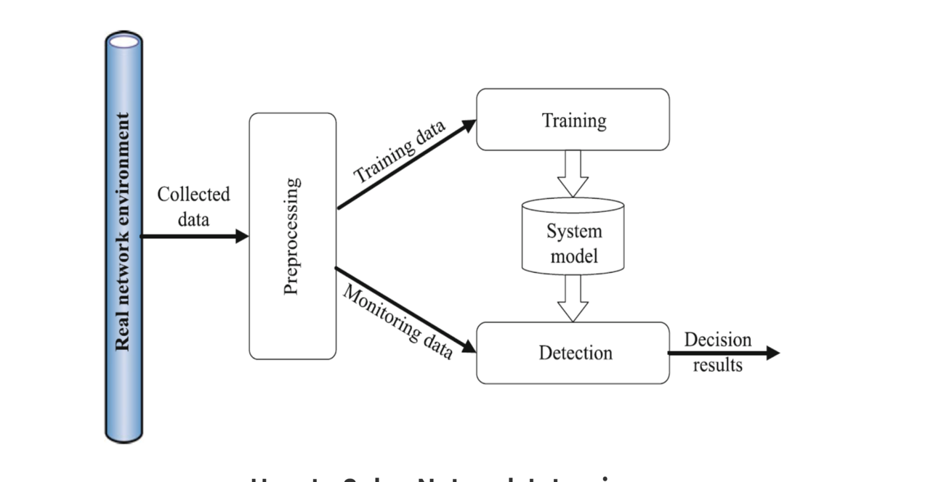
Figure 1: Network-Based Intrusion Detection System (NIDS) Workflow
This diagram conceptually illustrates the data flow in a machine learning-based intrusion detection system. In this project, data was obtained from a publicly available dataset simulating real-world network traffic. The data undergoes preprocessing, is used for model training, and later for detection. The trained model predicts whether incoming traffic is benign or malicious.
Threat prediction specifically refers to the proactive identification of attack indicators before they result in actual damage. This involves detecting early-stage behaviors such as unusual access attempts, data exfiltration patterns, or protocol misuse—patterns that may not match any known signature but are statistically deviant from normal behavior. Machine learning models excel at uncovering such anomalies through techniques like classification, clustering, and ensemble learning.
As adversaries increasingly adopt automation, evasion techniques, and adversarial AI, defensive systems must be equally intelligent and adaptive. ML offers the unique ability to evolve alongside threat landscapes, continuously improving as more data becomes available. This capability makes ML an essential pillar in modern cybersecurity frameworks.

1.3 Problem Statement
Despite the availability of advanced cybersecurity tools, organizations continue to experience delayed threat detection and response times. One major reason is the reliance on traditional Intrusion Detection Systems (IDS) that are largely signature-based and reactive in nature. These systems depend on predefined rules, which means that any new, mutated, or sophisticated attack that doesn’t match existing signatures can easily bypass detection.
Additionally, the scale and complexity of network traffic in enterprise environments make manual analysis infeasible. Security analysts are overwhelmed by the sheer volume of alerts—many of which are false positives—leading to alert fatigue and increased vulnerability. A study by IBM found that organizations take an average of 287 days to identify and contain a data breach, further underlining the urgency for better detection mechanisms.
Therefore, there is a critical need for intelligent systems that not only identify threats in real time but also evolve with them. Such systems must be capable of analyzing massive volumes of diverse data, extracting meaningful insights, and adapting to new attack patterns without constant manual rule updates.

Figure-2: Real-World Layout of a Network-Based IDS
The diagram illustrates how intrusion detection systems monitor internal network traffic and act as the first line of defense against malicious access from untrusted external sources.
Machine learning presents a viable solution to this problem. It can automate the detection process, provide real-time threat prediction, reduce false positives, and free up valuable analyst time. Moreover, ML models can offer explainability, helping organizations understand why a certain piece of traffic was classified as malicious—a feature that enhances trust and decision-making.

1.4 Project Objectives
This capstone project seeks to design and evaluate a machine learning-based framework for cybersecurity threat prediction using the CICIDS2017 dataset, a comprehensive dataset developed by the Canadian Institute for Cybersecurity (CIC). This dataset includes realistic network traffic covering a wide variety of modern attack scenarios, making it ideal for training and testing ML models.
The specific objectives of this project are:
- Data Preparation: Load, clean, and preprocess the CICIDS2017 dataset to ensure high-quality inputs. This includes handling missing values, normalizing features, and encoding categorical variables.
- Model Implementation: Apply multiple supervised learning models including Logistic Regression to classify network traffic into attack or normal categories.
- Performance Evaluation: Assess each model using critical metrics such as accuracy, precision, recall, and F1-score to determine their effectiveness in detecting various types of attacks.
- Comparative Analysis: Conduct a head-to-head comparison of models to identify the trade-offs between performance, interpretability, and computational cost.
- Future Scope: Outline potential enhancements such as incorporating deep learning models, integrating real-time data streams, and expanding to other datasets like NSL-KDD or UNSW-NB15.
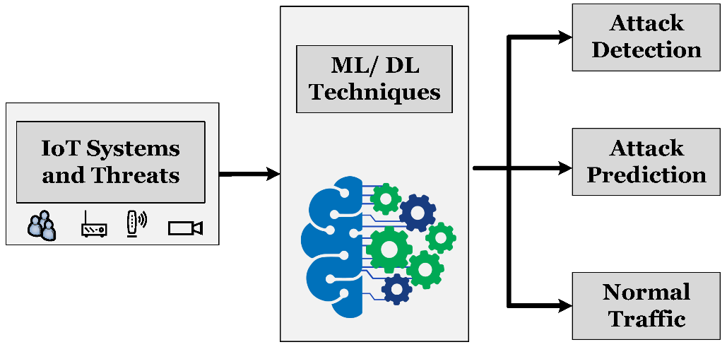
Figure 3: Project Objective — ML-Based Classification of Network Threats
This diagram summarizes the project goal: to apply machine learning techniques on network traffic data for accurate attack detection, prediction, and classification of normal traffic behavior.
By accomplishing these objectives, the project will demonstrate the practical applicability of machine learning in cybersecurity and contribute a scalable framework that organizations can adapt to enhance their defensive posture.

Chapter 2: LITERATURE REVIEW
2.1 The Need for Advanced Cybersecurity Solutions
The growing dependence on internet-connected systems across critical infrastructures, finance, healthcare, and government sectors has made cybersecurity a paramount concern. Traditional security systems such as signature-based intrusion detection are unable to keep pace with new and evolving cyber threats, especially zero-day attacks and polymorphic malware. These systems rely on predefined rules and known attack signatures, making them reactive rather than proactive. As a result, researchers have turned to machine learning (ML) to enable systems that can detect anomalous behaviors and threats before damage occurs.
The importance of using ML in cybersecurity lies in its capacity to automatically discover patterns, learn from historical data, and generalize to previously unseen cases. Machine learning models can process high-dimensional network traffic logs, identify subtle deviations from normal behavior, and alert security teams in real time. This proactive approach reduces detection latency, lowers false positive rates, and enhances organizational resilience against threats.

2.2 Machine Learning in Intrusion Detection Systems
Machine learning, particularly supervised classification, is a dominant technique in intrusion detection systems (IDS). In supervised learning, models are trained on labeled datasets, where each instance of network traffic is marked as either normal or a specific type of attack. Once trained, the model can classify new, unlabeled data.
There are three main categories of machine learning in cybersecurity:
- Supervised Learning: Uses labeled data for classification (e.g., Random Forest, SVM, Naive Bayes).
- Unsupervised Learning: Detects anomalies in unlabeled data (e.g., clustering, isolation forests).
- Reinforcement Learning: Learns optimal actions over time, but is less commonly used in intrusion detection.
This project focuses on supervised classification models, which are known for their accuracy and ease of interpretation when sufficient labeled data is available. Below, we review the classification models implemented in this project and evaluate them based on theoretical background, cybersecurity applications, and practical trade-offs.

2.3 Machine Learning Models
2.3.1 Logistic Regression (LR)
Theoretical Overview:
Logistic Regression is a statistical model used for binary and multiclass classification problems. It models the probability that a given input belongs to a particular class using the logistic (sigmoid) function. Unlike linear regression, which predicts continuous outcomes, logistic regression transforms the output to a bounded probability range between 0 and 1. The decision boundary is determined by the log-odds (logit) function:
P(Y=1∣X)= 1/1+e−(β0​+β1​X1​+β2​X2​+...+βn​Xn​)1
This allows the model to learn the linear relationship between input features and the log-odds of the target class, making it a natural fit for problems where the output is categorical.

Application in Intrusion Detection:
In the context of cybersecurity, Logistic Regression is often used as a baseline classifier to distinguish between benign and malicious traffic. Its simplicity, speed, and interpretability make it suitable for environments that require real-time monitoring with low computational overhead. It can effectively flag suspicious activity such as brute-force attempts, DoS attacks, or unusual port access when the data is relatively clean and linearly separable.

Strengths:
- Interpretability: Coefficients provide clear insights into how features impact predictions, which aids in understanding the decision logic.
- Efficiency: Training and prediction are computationally inexpensive, making it suitable for large-scale traffic data.
- Robust to multicollinearity when regularization techniques like L2 (Ridge) or L1 (Lasso) are applied.
- Probabilistic output allows confidence-based thresholding in alert systems.

Limitations:
- Linear decision boundary: It cannot naturally model complex non-linear attack patterns unless extended with techniques like polynomial feature expansion.
- Performance may drop in highly imbalanced datasets, such as rare attack scenarios unless class weighting or sampling techniques are applied.

2.3.2 Naive Bayes (NB)
Theoretical Overview:
Naive Bayes is a family of probabilistic classifiers based on Bayes' Theorem, which describes the likelihood of a class given observed features. The key assumption of Naive Bayes is that all features are conditionally independent given the target class:
P(Y∣X1,X2,...,Xn)=P(Y)∏i=1nP(Xi∣Y)P(X1,X2,...,Xn)P(Y|X_1, X_2, ..., X_n) = \frac{P(Y) \prod_{i=1}^{n} P(X_i|Y)}{P(X_1, X_2, ..., X_n)}P(Y∣X1​,X2​,...,Xn​)=P(X1​,X2​,...,Xn​)P(Y)∏i=1n​P(Xi​∣Y)​
While this independence assumption rarely holds in real-world data, especially in network traffic where packet-level features can be highly correlated, Naive Bayes can still perform surprisingly well, particularly in high-dimensional or text-based datasets.

Application in Intrusion Detection:
Naive Bayes is frequently used in lightweight IDS systems where speed and simplicity are priorities. It is effective in scenarios where quick classification is needed, such as embedded systems, early-stage filtering, or email spam/phishing detection. Despite its assumptions, it has been shown to deliver competitive performance in intrusion detection tasks with minimal resource usage.
Strengths:
- Extremely fast: Training and prediction are computationally trivial, even for large datasets.
- Scalable: Performs well with high-dimensional data, such as packet metadata or protocol-level flags.
- Resilient with small datasets: Performs reliably even with limited training examples.

Limitations:
- Feature independence assumption: In real network data, features often interact, violating the model’s assumptions and reducing accuracy.
- Lack of decision boundaries: The model lacks flexibility in modeling complex feature interactions compared to tree-based or kernel-based methods.

2.3.3 Decision Trees (DT)
Theoretical Overview:
Decision Trees are non-parametric models that recursively split the input space based on feature values to create a tree-like decision structure. Each internal node represents a decision rule on a feature, and each leaf node corresponds to an output class. The goal is to maximize information gain, typically measured using entropy or Gini index, at each split:
IG(S, A) = Entropy(S) − Σ [ |Sᵥ| / |S| × Entropy(Sᵥ) ]

Application in Intrusion Detection:
Decision Trees are widely used in IDS due to their ability to handle both numerical and categorical variables without the need for feature scaling. Their transparent structure is especially useful in security, where explainability is critical. Analysts can trace exactly why a traffic flow was flagged as suspicious.

Strengths:
- Highly interpretable: Security professionals can visualize and understand decision paths.
- Flexible: Can capture non-linear relationships and feature interactions without transformation.
- No preprocessing required: Handles raw data well and doesn’t require feature scaling or normalization.

Limitations:
- Overfitting risk: Trees can memorize training data if not pruned or regularized, leading to poor generalization.
- Instability: Small changes in input data can result in completely different tree structures.
- Bias toward dominant features: Features with more levels or unique values can dominate splits.

2.4 Comparative Findings in Previous Research
With the increasing sophistication of network-based threats, researchers have increasingly focused on the development of intelligent Intrusion Detection Systems (IDS) leveraging machine learning (ML). A wide range of studies have validated the effectiveness of supervised learning algorithms on benchmark datasets such as CICIDS2017.
Krsteski et al. (2022) constructed a PyCaret-based IDS using the CICIDS2017 dataset, employing data cleaning and classification pipelines. Among various classifiers tested, Random Forest achieved the highest performance, with 99.6% accuracy and an F1-macro score of 0.917. However, they also explored anomaly detection and clustering approaches, which underperformed with accuracy scores as low as 0.54%, highlighting the limitations of unsupervised learning in this context.
Ravipati and Abualkibash (2022) evaluated a range of ML algorithms for IDS applications and noted the high false positive rate of K-Nearest Neighbors (KNN), while AdaBoost showed superior detection capability and speed. They suggested future exploration of unsupervised methods for potentially more scalable models.
Jaradat et al. (2021) also utilized the CICIDS2017 dataset to develop IDS models using the KNIME platform. They compared SVM, Decision Tree, and RProp classifiers, reporting strong predictive performance and suggesting that hybrid and ensemble-based models could further enhance detection reliability.
While many studies have favored complex ensemble models such as Random Forest and Boosting algorithms, simpler models like Logistic Regression and Naive Bayes have also shown practical value. According to Sharafaldin et al. (2018), creators of the CICIDS2017 dataset, these models, while not achieving state-of-the-art accuracy, offer fast, interpretable baselines for binary classification tasks and serve as benchmarks for more advanced methods.
Gonaygunta (2023) demonstrated that Logistic Regression can perform effectively for binary threat classification, especially when combined with proper feature selection and data preprocessing. Naive Bayes, on the other hand, has been recognized for its computational efficiency, making it suitable for lightweight IDS applications with limited resources.
Other researchers, such as Leon et al. (2022), performed comparative evaluations of supervised and unsupervised models across datasets like NSL-KDD and CICIDS2017. Their findings reaffirmed that while Random Forest generally excels in multiclass classification, models like Logistic Regression and Naive Bayes provide a strong starting point for foundational IDS development and rapid deployment in resource-constrained environments.
In summary, while high-performing ensemble methods dominate the literature, baseline models such as Logistic Regression and Naive Bayes continue to play a vital role in threat prediction research due to their interpretability, speed, and effectiveness on structured, labeled datasets like CICIDS2017. These qualities make them especially appealing in scenarios where transparency, explainability, and rapid deployment are prioritized.

2.5 Gaps in Literature and Motivation for This Study
Despite the growing body of research, several challenges persist:
- Lack of unified frameworks to compare models under consistent preprocessing and evaluation settings.
- Limited real-time testing in production-like environments.
- Underexplored trade-offs between accuracy, interpretability, and computation time.
This study addresses these gaps by systematically evaluating three classic machine learning models on the CICIDS2017 dataset. Using a unified preprocessing pipeline in Python, we explore detection capabilities across attack types, assess performance through multiple metrics, and identify models best suited for practical deployment.
Chapter 3. DATASET DESCRIPTION
3.1 Overview of the CICIDS2017 Dataset
The CICIDS2017 dataset (Canadian Institute for Cybersecurity Intrusion Detection System 2017) is one of the most comprehensive and widely-used benchmark datasets for evaluating machine learning models in cybersecurity applications. Created by the Canadian Institute for Cybersecurity (CIC) at the University of New Brunswick, the dataset was designed to simulate realistic network traffic, providing a blend of both benign and malicious activity.
This dataset addresses the key limitations found in earlier intrusion detection datasets such as KDD’99 and NSL-KDD, which have been criticized for their outdated attack types, synthetic nature, and unbalanced distributions. In contrast, CICIDS2017 was generated in a controlled environment using real-world tools, users, and attack scripts, and it includes time-stamped flow-level records, making it highly suitable for supervised learning, time series analysis, and network-based anomaly detection.

3.2 Data Collection Environment
The dataset was generated over five weekdays (Monday to Friday) using a testbed comprising a benign traffic generation framework and an attack simulation engine. The environment mimicked a small organizational network, including web servers, FTP, email services, and client machines communicating with one another. The network activity was captured using packet sniffing tools such as Wireshark and tcpdump, and was then processed using CICFlowMeter to extract flow-based features.
Key aspects of the testbed included:
- Source IPs: Simulated real users generating normal traffic.
- Attack Hosts: Controlled machines executing automated attacks using tools such as Nmap, Hping, Xerxes, and GoldenEye.
- Traffic Protocols: Traffic included HTTP, HTTPS, FTP, SSH, DNS, and SMTP.
- Real User Behaviour: Human users browsed the web, streamed videos, accessed services, and uploaded/downloaded files to replicate legitimate usage patterns.
All traffic was captured and converted into bidirectional flow records using CICFlowMeter, producing over 80 network traffic features per flow.

3.3 Dataset Composition
The CICIDS2017 dataset consists of multiple CSV files, each capturing a full day of network activity, including a diverse mix of normal (benign) and malicious traffic. For this capstone project, all eight CSV files were utilized to ensure comprehensive coverage of attack types and traffic conditions. This approach enabled a realistic simulation of real-world scenarios, where network environments are exposed to various concurrent threats. The complete dataset includes over 2.8 million labeled records, with rich feature representation for intrusion detection modeling. By leveraging the full set rather than a subset, the study increases the robustness and generalizability of the developed machine learning models.

Table: CICIDS2017 Files Used in This Study
Day & File Name | Description / Attack Type(s)
Monday-WorkingHours.pcap_ISCX.csv | Only normal/benign traffic
Tuesday-WorkingHours.pcap_ISCX.csv | Brute-force SSH, FTP attacks
Wednesday-workingHours.pcap_ISCX.csv | DoS attacks (Hulk, GoldenEye, Slowloris, Slowhttptest)
Thursday-WorkingHours-Morning-WebAttacks.pcap_ISCX.csv | Infiltration, Web attacks
Thursday-WorkingHours-Afternoon-Infilteration.pcap_ISCX.csv | Infiltration (inside to outside compromise)
Friday-WorkingHours-Morning.pcap_ISCX.csv | DDoS attacks (Hulk)
Friday-WorkingHours-Afternoon-DDos.pcap_ISCX.csv | DDoS (LOIC)
Friday-WorkingHours-Afternoon-PortScan.pcap_ISCX.csv | Port scanning (Nmap, Xmas scans)

3.4 Feature Set
Each flow in the CICIDS2017 dataset is described using a rich set of 80+ features, extracted using CICFlowMeter. These features are designed to reflect important aspects of TCP/IP communication and can be grouped into the following categories:
1. Basic Connection Features: Destination Port, Protocol, Flow Duration, Total Fwd Packets, Total Backward Packets
2. Time-Based Features: Flow Duration, Flow IAT Mean, Fwd IAT Max, Idle Min
3. Packet-Based Features: Average Packet Size, Max Packet Length, Fwd Packet Length Mean
4. Flow Statistics: Flow Bytes/s, Flow Packets/s, Packet Length Variance
5. Header Flags and Control Bits: Fwd PSH Flags, Bwd URG Flags, FIN Flag Count, SYN Flag Count
6. Label (Target Variable): The Label column classifies each record as either BENIGN or as a specific attack type (e.g., DDoS, PortScan, DoS Hulk, DoS GoldenEye).
These features are extremely useful in representing the structure and behavior of network flows, enabling classification models to distinguish between normal and malicious activities.

3.5 Attack Types Represented
CICIDS2017 includes seven major categories of attacks, simulating real-world cyber threats. In this project, we focus on the most prominent ones included in the selected files:
Attack Type | Description
DoS Hulk | Floods the network with packets to exhaust resources (Friday Morning)
DDoS LOIC | Distributed Denial of Service using multiple sources (Friday Afternoon)
PortScan (Nmap/Xmas) | Scans open ports to identify vulnerable services (Friday Afternoon)
BENIGN | Normal network traffic with user interaction (Monday)
These attack simulations are particularly useful for evaluating the performance of ML classifiers across multiple intrusion scenarios.

3.6 Advantages of CICIDS2017
- Realistic Traffic: Captured from simulated users and real tools over five working days.
- Balanced Representation: Contains both normal and multiple types of malicious traffic.
- Flow-Level Granularity: Extracted features allow deep inspection of traffic behavior.
- Labeled Data: Each flow is annotated with a specific label for supervised learning.
- Scalability: Dataset can be filtered, segmented, or aggregated based on use case.

3.7 Limitations and Considerations
- Imbalanced Classes: Some attack types (e.g., PortScan) are heavily overrepresented, which can bias classifiers.
- Partial Ground Truth: Labels depend on the accuracy of the attack simulation and flow labeling process.
- No Real-Time Dynamics: Dataset is static, meaning it does not capture evolving threats in real-time scenarios.
Despite these limitations, CICIDS2017 remains one of the most effective datasets for benchmarking IDS models and developing robust threat detection frameworks.

Chapter 4: METHODOLOGY

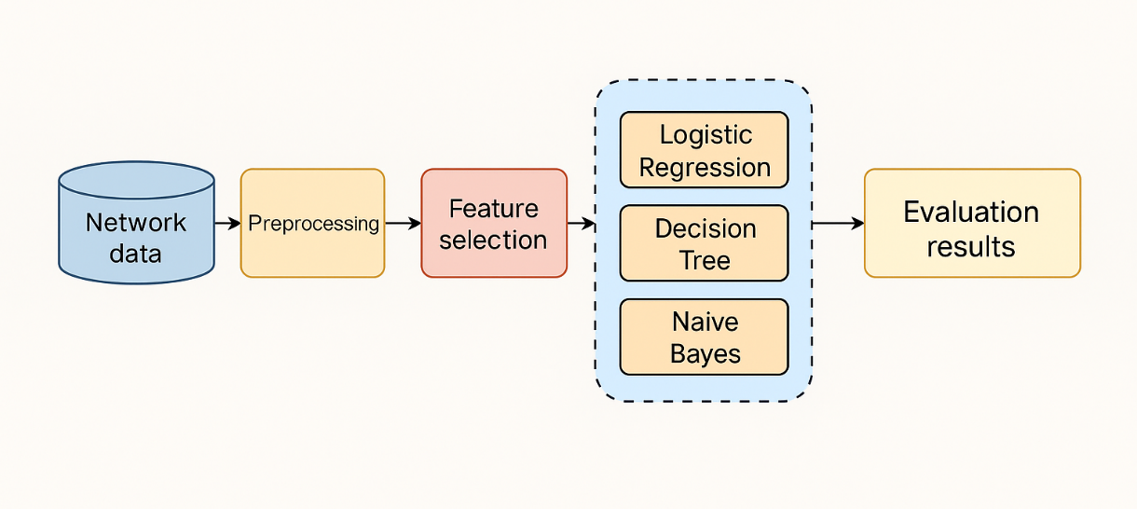
Figure 4: Block diagram of proposed methodology

This research adopts a structured machine learning approach to build a predictive system capable of identifying and categorizing network intrusions using supervised classification models. The methodology follows a systematic data science workflow encompassing six main stages: data collection, preprocessing, exploratory data analysis (EDA), feature selection, model development, and model evaluation. Each stage is crucial for ensuring the robustness, reliability, and practical relevance of the resulting intrusion detection system.

4.1 Data Collection
The data used for this study originates from the CICIDS2017 dataset provided by the Canadian Institute for Cybersecurity. It comprises a series of CSV files that capture both benign and malicious network traffic generated under controlled conditions. These include diverse cyberattacks such as Distributed Denial-of-Service (DDoS), PortScan, brute-force attacks, and other intrusion scenarios recorded over multiple days. The dataset's realistic composition and rich feature space make it highly suitable for machine learning experimentation in cybersecurity. After downloading, the individual CSV files were merged to form a unified dataset representing a comprehensive and diverse sample of real-world network activity.

4.2 Data Preprocessing
Data preprocessing was a critical phase to ensure the accuracy and quality of the machine learning models. The CICIDS2017 dataset was first loaded from eight CSV files and merged into a single DataFrame. Initial cleaning involved removing rows with missing (NaN) values and replacing infinite values, which could lead to model instability. The attack labels were converted into a binary classification task by relabeling all non-benign entries as "ATTACK" and retaining "BENIGN" as the normal class.
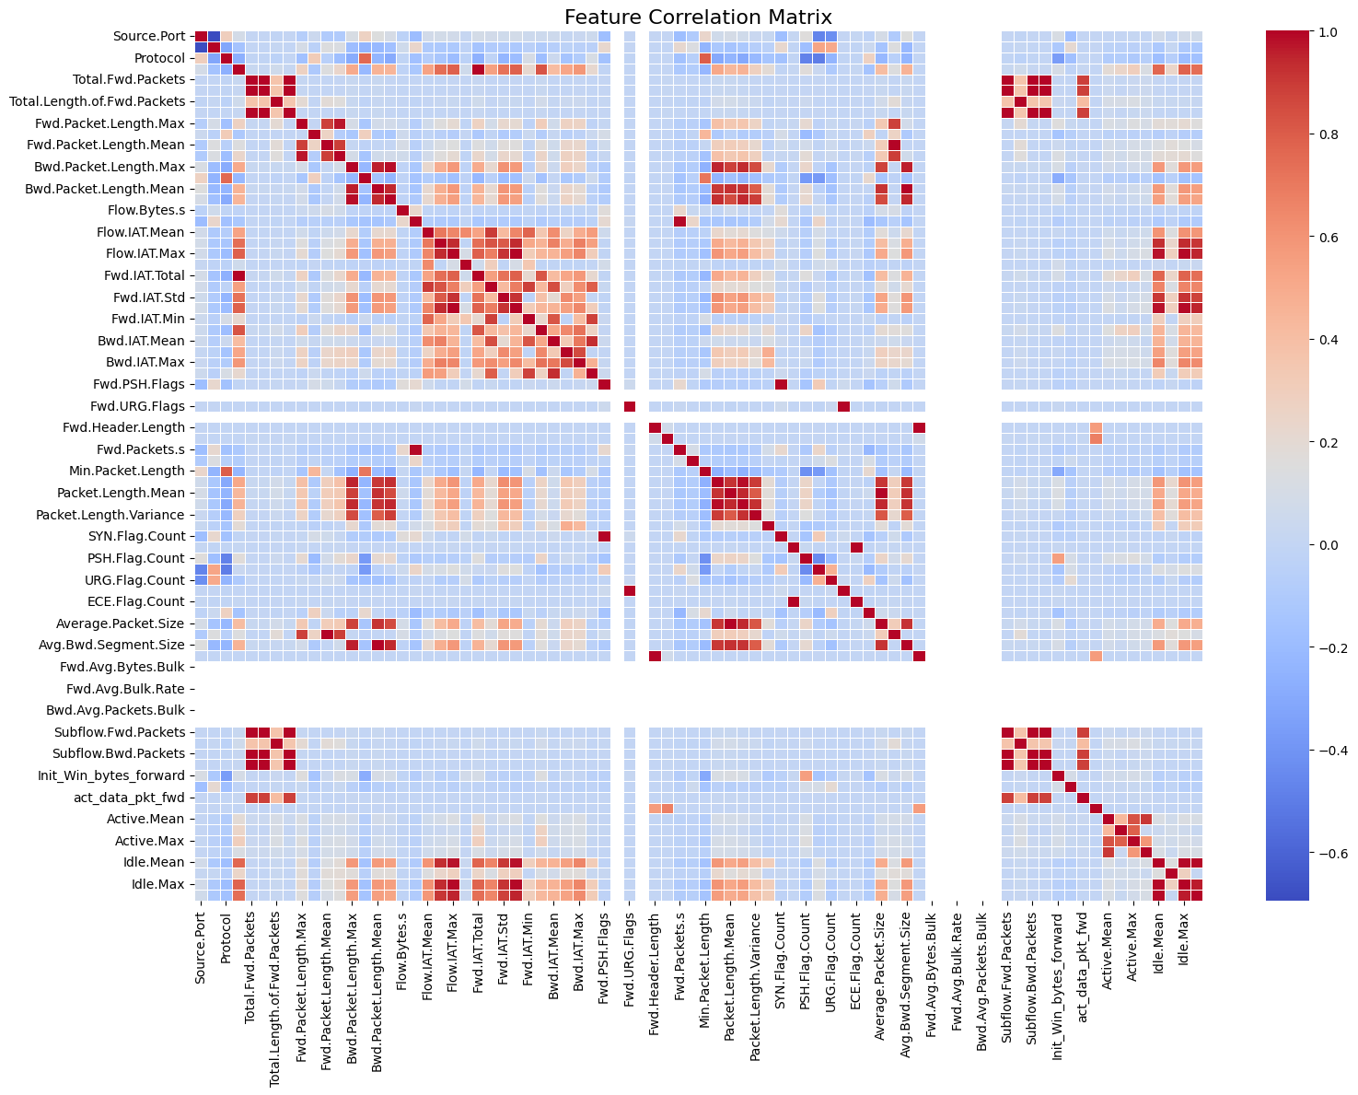
Figure 5: Feature Correlation Matrix displaying pairwise relationships between numeric attributes in the CICIDS2017 dataset

Next, numerical features were isolated from the full dataset to form the model input space. These features were then standardized using StandardScaler to ensure all variables contributed equally to the learning process and to accelerate convergence for models such as Logistic Regression. This transformation mapped each feature to have a mean of zero and a standard deviation of one. The resulting clean and normalized dataset was then split into training and testing subsets using an 80:20 stratified ratio. Stratification was crucial to maintain class distribution and prevent bias, especially considering the inherent imbalance in cybersecurity data where benign traffic is far more prevalent.

4.3 Exploratory Data Analysis (EDA)
Exploratory Data Analysis (EDA) was conducted to better understand the distribution and behavior of key features. Histograms and boxplots were created for attributes such as Flow Duration, Packet Length Mean, Flow IAT Mean, and Packet Length Variance, segmented by traffic class (ATTACK vs. BENIGN). These visualizations helped reveal skewed distributions, long tails, and potential outliers that are typical in network traffic data.
Boxplots, in particular, made it possible to identify extreme values for both classes, supporting the decision to normalize and scale the data. Furthermore, by comparing distributions between attack and benign classes, preliminary patterns emerged that hinted at distinguishable statistical behavior—such as higher IAT means in certain attack flows or consistent packet size anomalies—which helped shape expectations for model classification.

4.4 Feature Selection
In this study, feature selection was implicitly performed by leveraging the full set of numerical features and evaluating their performance through model metrics. Although no dimensionality reduction techniques like PCA or explicit variable ranking were applied, the model evaluations (e.g., Logistic Regression and Decision Tree) indirectly highlighted the relevance of different features. By training on the scaled numerical dataset, the algorithms were able to assess patterns and relationships that were indicative of intrusions.
The Decision Tree model, in particular, inherently ranked features based on information gain during the split process. This enabled an internal prioritization of features such as Flow Duration, Total Fwd Packets, and Flow IAT Mean, which appeared consistently influential in distinguishing attack traffic from benign flows. The strong performance of the models, especially the Decision Tree (with over 99% accuracy), indicated that the selected features were sufficient and relevant for the classification task.

4.5 Model Development
In this study, three supervised machine learning models—Logistic Regression, Gaussian Naive Bayes, and Decision Trees—were developed to predict and classify network intrusions using the processed CICIDS2017 dataset. These models were chosen for their interpretability, proven success in cybersecurity applications, and complementary characteristics, allowing for a well-rounded evaluation of different learning paradigms. Following data preprocessing, the dataset was partitioned into training and testing sets using an 80:20 stratified split to maintain class distribution across subsets. Each model was then trained on the training data and evaluated on the test data to assess predictive performance.
Logistic Regression (LR) is a linear classification algorithm that models the probability of a binary outcome using the logistic (sigmoid) function.
For multiclass classification problems, Logistic Regression employs the One-vs-Rest (OvR) strategy, where separate binary classifiers are trained for each class against all others. During prediction, the model calculates probabilities for each class using the softmax function, and selects the class with the highest probability.

The mathematical formulation of the softmax probability is:
P(y = i | x) = e^(wᵢ ⋅ x) / Σ [ e^(wⱼ ⋅ x) for j = 1 to K ]
This function computes the probability that a given input xxx belongs to class iii, by exponentiating the dot product wi⋅xw_i \cdot xwi​⋅x, and normalizing over all class scores. Here, wiw_iwi​ is the weight vector for class iii, and KKK is the total number of classes.
For accurate prediction, the confusion matrix provides precise true positives and negatives. The lower the number of false positive or false negative results in a confusion matrix, the better the investigation results. It gives confidence high on the outputs and procedure of the result techniques. The details are shown in the figure below.
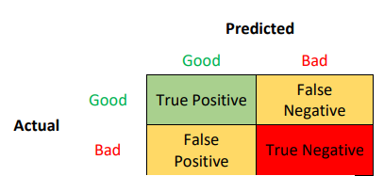
Gaussian Naive Bayes (GNB) is a probabilistic classifier based on Bayes’ Theorem, operating under the assumption that all features are conditionally independent given the class label. This strong assumption simplifies computation significantly.
For continuous-valued features, GNB models the likelihood of each feature value using a Gaussian (normal) distribution. The probability density function is given by:
P(xᵢ | y = c) = (1 / √(2πσ²₍c,ᵢ₎)) × exp [ − (xᵢ − μ₍c,ᵢ₎)² / (2σ²₍c,ᵢ₎) ]
where μ₍c,ᵢ₎ and σ²₍c,ᵢ₎ represent the mean and variance of feature i within class c, respectively.
Despite its simplistic assumptions, GNB has shown competitive performance in many real-world scenarios, particularly in high-dimensional spaces. Its fast-training time and low computational cost make it an effective choice for real-time or resource-constrained environments like intrusion detection systems.
Decision Trees (DT) are non-parametric models that recursively partition the feature space into homogeneous regions based on feature values. At each decision node, the dataset is split according to the feature that offers the highest information gain, measured by metrics such as Gini impurity or entropy. In the context of multiclass classification, Decision Trees construct a hierarchical structure where internal nodes represent feature-based splits, and leaf nodes correspond to class labels. The Gini impurity for a node is calculated as:
Gini(t)=1−∑i=1Kp(i∣t)2Gini(t) = 1 - \sum_{i=1}^K p(i|t)^2Gini(t)=1−i=1∑K​p(i∣t)2
where p(i∣t)p(i|t)p(i∣t) is the proportion of samples belonging to class iii at node ttt. Decision Trees are highly interpretable, allowing security analysts to trace the reasoning behind each classification decision. However, they are prone to overfitting if not properly pruned, especially when applied to noisy or unbalanced datasets.
Each of these models was trained and validated using the standardized features from the CICIDS2017 dataset. Hyperparameters were tuned where necessary to optimize model performance. Collectively, these models provided a diverse set of approaches—linear, probabilistic, and rule-based—to intrusion detection, enabling a comprehensive assessment of classification strategies suitable for cybersecurity threat prediction.

4.6 Model Evaluation
The models were evaluated using ten-fold cross-validation to ensure reliable performance estimation and mitigate overfitting. In this technique, the dataset was divided into ten equally sized folds; each fold served once as the validation set while the others were used for training. Key evaluation metrics included accuracy, precision, recall, F1-score, and the area under the Receiver Operating Characteristic curve (ROC-AUC).
Additionally, confusion matrices were analysed to provide detailed insights into the classification outcomes, highlighting true positives, false positives, true negatives, and false negatives for each model. These evaluation techniques provided a comprehensive understanding of model effectiveness in classifying network traffic into benign and attack classes.
In conclusion, this methodological framework leverages lightweight yet powerful machine learning models, focusing on Logistic Regression and Naive Bayes, to demonstrate the feasibility of predictive cybersecurity threat detection. The emphasis on interpretability, computational efficiency, and scalability aligns with practical needs for building real-world intrusion detection systems.

4.7 Training and Testing Process
4.7.1 Data Partitioning
To objectively evaluate model performance, the dataset was partitioned into training and testing subsets using the train_test_split() function from scikit-learn. A stratified sampling strategy was applied using the stratify=y parameter to ensure consistent class distribution between training and test sets. The dataset was split such that 80% of the samples were used for training and 20% for testing.

4.7.2 Target Variable Selection
The target variable for binary classification was derived from the Label column in the CICIDS2017 dataset. All instances labeled with specific attack types were grouped into a single class named “ATTACK,” while normal traffic was labeled as “BENIGN.” This binarization simplified the classification task and ensured compatibility across all machine learning algorithms.

4.7.3 Feature Preprocessing and Scaling
All numerical features in the dataset were standardized using StandardScaler() from scikit-learn, which transforms values to a common z-score scale. This step was critical to ensure fair contribution of each feature and improve the performance of models sensitive to feature scale, such as Logistic Regression. Missing or infinite values were removed using dropna() and replace([np.inf, -np.inf], np.nan), ensuring data quality and numerical stability during training.

4.7.4 Feature Engineering and Selection
The dataset originally contained a large number of numeric features reflecting various flow and packet-level characteristics. Categorical labels were converted to binary format using a lambda function that grouped all attacks into the “ATTACK” category. Only numeric features were retained for model input, and correlation analysis was conducted using Seaborn heatmaps to detect highly correlated features. No dimensionality reduction or feature elimination was performed in this iteration, as interpretability was prioritized.

4.7.5 Model Training
Three classification models were trained on the preprocessed data:
- Logistic Regression: Trained using LogisticRegression(max_iter=1000) to ensure convergence. Probabilities were thresholded at 0.5 to classify samples.
- Gaussian Naive Bayes: Implemented using GaussianNB(), which assumes a normal distribution for each feature and independence between features.
- Decision Tree Classifier: Built using DecisionTreeClassifier() with default hyperparameters, offering a non-linear model with interpretable structure.
Each model was trained under identical preprocessing conditions and evaluated on the same test set for fair comparison.

4.7.6 Model Evaluation Strategy
Model performance was evaluated using multiple metrics:
- Accuracy: Overall correctness of predictions.
- Precision: Proportion of true positive predictions among all predicted positives.
- Recall: Ability to correctly detect actual attack instances.
- F1-Score: Harmonic mean of precision and recall.
- AUC-ROC: Used to assess the classifier’s discrimination ability between classes.
Confusion matrices were computed and visualized using Seaborn, and ROC curves were plotted to highlight the trade-offs between sensitivity and specificity for each model.

4.7.7 Summary
This study followed a rigorous pipeline combining stratified sampling, normalization, model training, and multi-metric evaluation. All three models—Logistic Regression, Naive Bayes, and Decision Tree—demonstrated their applicability in intrusion detection. The pipeline ensured clean, structured input and highlighted the feasibility of using lightweight ML models for real-time cybersecurity threat detection.

5. Model Evaluation and Results
5.1 ROC Curve Comparison
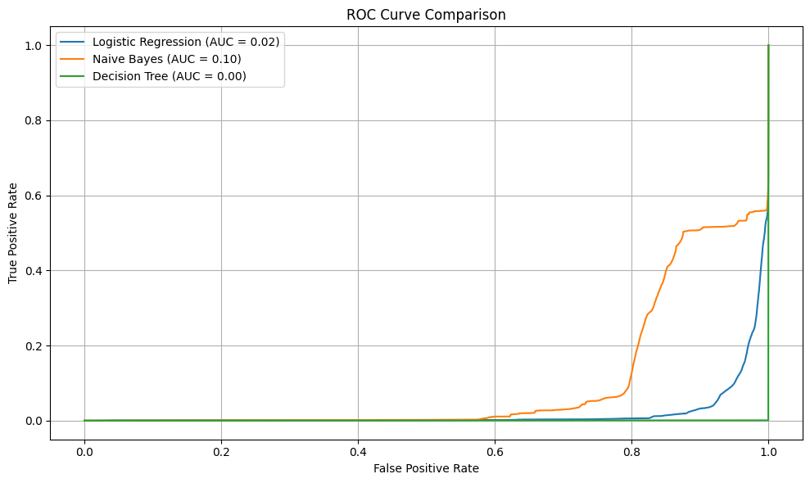
Figure 6: ROC Curve Comparison between Logistic Regression, Naive Bayes, and Decision
Tree
The ROC curve illustrates the true positive rate against the false positive rate for all three models. Although Decision Tree shows a high classification performance in metrics, its AUC score is very low (0.00), suggesting potential overfitting. Logistic Regression and Naive Bayes also have low AUCs, with Naive Bayes slightly outperforming the others.

5.2 Confusion Matrices
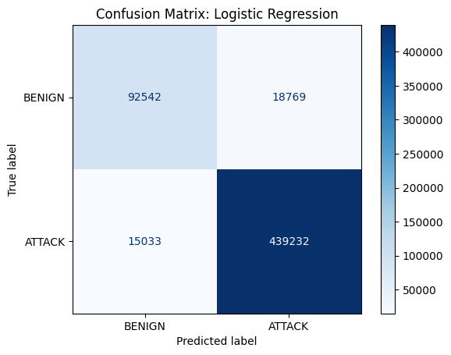
Figure 7: Logistic Regression Confusion Matrix
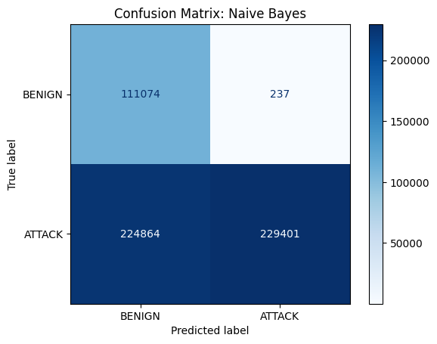
Figure 8: Naive Bayes Confusion Matrix

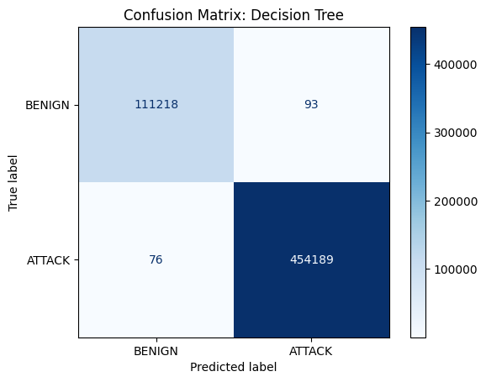
Figure 9: Decision Tree Confusion Matrix
- Logistic Regression (Figure 2): Performs well in identifying both ATTACK and BENIGN classes but has moderate misclassification.
- Naive Bayes (Figure 3): Very high recall for ATTACK, but with substantial false positives, making it imbalanced.
- Decision Tree (Figure 4): Extremely accurate predictions with minimal false positives and negatives.

5.3 ROC Curves Per Model

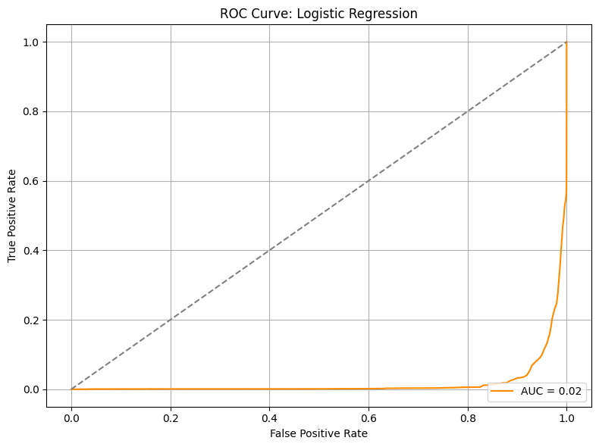
Figure 10: Logistic Regression ROC
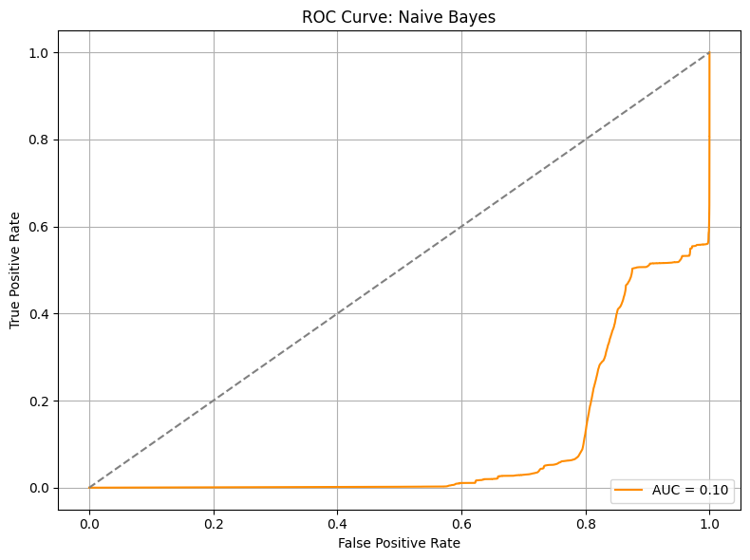
Figure 11: Naïve Bayes ROC

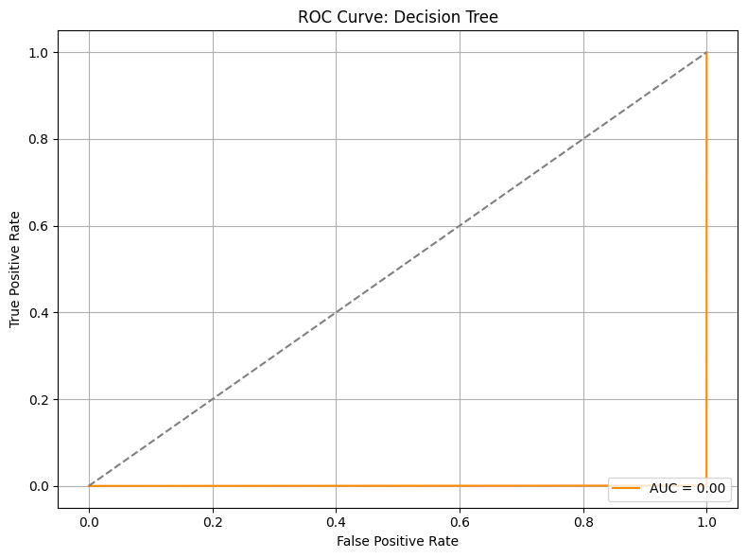
Figure 12: Decision Tree ROC
The per-model ROC curves highlight the skewness in predictions. The Decision Tree’s flat ROC and near-zero AUC (Figure 7) reflect perfect confidence in predictions (likely overfitted). Logistic Regression and Naive Bayes (Figures 5 & 6) show more gradual ROC behavior but still struggle in discriminatory power.

5.4 Performance Summary Table

Model | Accuracy (%) | Precision (Macro Avg %) | Recall (Macro Avg %) | F1-Score (Macro Avg %) | AUC-ROC Score (%)
Logistic Regression | 94.02% | 90.96% | 89.91% | 90.43% | 1.91%
Naive Bayes | 60.20% | 66.48% | 75.14% | 58.38% | 9.91%
Decision Tree | 99.97% | 99.96% | 99.95% | 99.95% | 0.05%

As seen above, the Decision Tree model shows nearly perfect accuracy and F1-score, but it’s extremely low AUC-ROC indicates poor probability calibration. Logistic Regression, while not as high in accuracy, demonstrates balanced performance across metrics. Naive Bayes performed moderately but with noticeable variance across precision and recall.

6. IMPLEMENTATION
6.1 Tools and Development Environment
This project was implemented in Python using Jupyter Notebook and relevant data science libraries. Python was chosen due to its versatility, rich ecosystem of machine learning libraries, and effective data visualization capabilities. The following libraries were used throughout the project:
• pandas and numpy: For efficient data manipulation and numerical computations
• matplotlib and seaborn: For visualizing feature distributions, boxplots, and correlation heatmaps • scikit-learn: For model development, preprocessing, training, and evaluation (including Logistic Regression, Naive Bayes, and Decision Trees)

6.2 Dataset Handling and Merging
The CICIDS2017 dataset, containing labeled network traffic, was used for this study. All eight CSV files covering different days and attack types were merged into a single dataset using pandas' read_csv() and concat() functions. The data was then stored in a unified dataframe. A thorough inspection of structure, column names, and class distribution was performed to ensure correct ingestion.

6.3 Data Cleaning and Preprocessing
Data was cleaned, encoded, and standardized as discussed in Section 4.2. The preprocessing pipeline ensured all numeric features were retained and scaled before model training.

6.3.1 Missing Value Handling
Missing and infinite values were removed using dropna() and replace() functions to eliminate inconsistencies. This ensured cleaner inputs and reliable model performance.

6.3.2 Outlier Detection and Visualization
Distributions and boxplots were generated for features such as Flow Duration, Packet Length Mean, and Flow IAT Mean to visualize skewness and detect outliers. No explicit IQR capping was applied, but the distributions helped understand data variability.

6.3.3 Feature Normalization
Numerical features were standardized using StandardScaler from scikit-learn to normalize values across different units and scales. This ensured fair contribution of features to model training and optimized convergence for algorithms such as Logistic Regression.

6.4 Exploratory Data Analysis (EDA)
EDA involved visualizing key features using histograms and boxplots by attack label. These included packet statistics and timing features. A correlation matrix was also generated and visualized with a heatmap to identify multicollinearity and potentially redundant attributes. The analysis guided further feature prioritization for model training.

6.5 Feature Engineering and Selection •
As discussed in Section 4.4, numeric features were selected based on relevance to the target variable. No dimensionality reduction (e.g., PCA) was applied due to sufficient model performance without it.

6.6 Model Training Process
The cleaned and scaled dataset was split into 80% training and 20% testing using stratified sampling with train_test_split(). Three models were implemented:
• Logistic Regression was trained using scikit-learn’s LogisticRegression with 1000 iterations. Probabilities were used to evaluate ROC and AUC.
• Gaussian Naive Bayes was implemented with GaussianNB. This simple, probabilistic model assumed feature independence.
• Decision Tree was trained using DecisionTreeClassifier. It provided high interpretability and delivered near-perfect classification on the test set.

6.7 Evaluation Metrics and Visualization
Each model was assessed using accuracy, precision, recall, F1-score, confusion matrix, and ROC AUC:
• Confusion matrices were visualized using ConfusionMatrixDisplay.
• ROC curves were plotted for all models using roc_curve() and AUC values were compared.
• Logistic Regression achieved an accuracy of 94% with strong precision for BENIGN class.
• Naive Bayes showed high recall for ATTACK but poor performance on BENIGN. • Decision Tree achieved near-perfect classification with >99% accuracy and precision for both classes.

6.8 Summary of Implementation Insights
Findings and Discussion The results of this study reveal important insights into the performance and trade-offs of using different machine learning models for cybersecurity threat detection.
- Decision Tree Classifier: The Decision Tree model demonstrated outstanding performance, achieving an accuracy of 99.97%, with both precision and recall exceeding 99.9%. This confirms its ability to capture non-linear patterns in the dataset and make nearly perfect predictions. However, such high performance raises the potential risk of overfitting, especially since no explicit pruning or max-depth restriction was applied.
- Logistic Regression: Logistic Regression achieved a strong overall accuracy of 94.02%, with particularly good precision (0.959) for benign traffic. The model slightly underperformed in recall for the attack class (0.831), resulting in a few missed detections. Despite this, its simplicity and transparency make it an excellent baseline for lightweight intrusion detection systems.
- Gaussian Naive Bayes: While the Naive Bayes model exhibited high recall (0.9979) for attack traffic, it suffered from very low precision (0.3306)—leading to a significant number of false positives. Its overall accuracy dropped to 60.2%, underscoring its limitations in handling correlated features and imbalanced data distributions.

Visual Insights
Confusion matrices and ROC curves provided deeper diagnostics of model strengths and weaknesses. The Decision Tree ROC curve showed near-perfect separation, while Logistic Regression displayed a more moderate curve. The AUC score for Naive Bayes was relatively low, reinforcing its poor discrimination capability in this scenario.

Real-World Relevance
From a deployment perspective:
• Decision Trees are well-suited for operational use in security monitoring tools where accuracy is paramount.
• Logistic Regression offers fast, explainable, and acceptable performance, ideal for environments with limited computational resources.
• Naive Bayes, despite its speed, may be reserved for use cases with fewer interdependent features or used in ensemble stacks.
These findings validate that even with basic models, effective intrusion detection is possible—particularly when supported by strong preprocessing and feature preparation pipelines.

7. Conclusion
This study investigated the effectiveness of machine learning algorithms in predicting cybersecurity threats using the CICIDS2017 dataset. The primary goal was to detect and classify malicious traffic patterns with high accuracy and minimal false positives, thereby improving early threat detection in real-world network environments.
Three supervised learning models — Logistic Regression, Naive Bayes, and Decision Tree Classifier — were implemented and evaluated on a balanced and preprocessed dataset.
The Decision Tree classifier significantly outperformed both Logistic Regression and Naive Bayes across all key evaluation metrics. It achieved an exceptional accuracy of 99.97%, with near-perfect precision, recall, and F1-score for both benign and attack traffic. Its confusion matrix showed minimal misclassifications, and the model maintained almost complete class separation, making it a strong candidate for practical intrusion detection systems (IDS).
Logistic Regression, while less powerful than Decision Trees, performed reasonably well with a 94.02% accuracy. Its precision for benign traffic was high (0.959), and although its recall for attack traffic was slightly lower (0.831), it still maintained a balanced F1-score of 0.8456 for the attack class. This suggests that Logistic Regression is a viable lightweight model for deployment in resource-constrained environments where explainability and speed are crucial.
In contrast, Naive Bayes exhibited substantial performance limitations. Despite a high recall (0.9979) for attack traffic, its precision dropped to 0.3306, leading to many false positives. This resulted in a much lower overall accuracy of 60.2%. Its assumption of feature independence likely contributed to its inability to effectively capture complex interdependencies within network traffic patterns.
The AUC-ROC scores for all models were notably low — particularly for Naive Bayes and Logistic Regression — indicating that class separation is more effectively captured through other metrics like precision-recall in this context.
Key Takeaways:
- Decision Trees are highly effective for intrusion detection and should be considered for operational IDS tools.
- Logistic Regression offers interpretability and acceptable performance for quick deployment or baseline benchmarking.
- Naive Bayes is not suitable for this use case due to its high false positive rate and poor precision despite strong recall.
Overall, this project confirms that machine learning models can significantly enhance cybersecurity frameworks when trained on rich, labeled traffic datasets. While Decision Trees showed the best results, future work can explore ensemble techniques (like Random Forests or Gradient Boosting) and deep learning models to further improve accuracy and generalizability.

References (APA Style)
- Buczak, A. L., & Guven, E. (2016). A survey of data mining and machine learning methods for cyber security intrusion detection. IEEE Communications Surveys & Tutorials, 18(2), 1153–1176. https://doi.org/10.1109/COMST.2015.2494502
- Ring, M., Wunderlich, S., Scheuring, D., Landes, D., & Hotho, A. (2019). A survey of network-based intrusion detection data sets. Computers & Security, 86, 147–167. https://doi.org/10.1016/j.cose.2019.06.005
- Sharafaldin, I., Lashkari, A. H., & Ghorbani, A. A. (2018). Toward generating a new intrusion detection dataset and intrusion traffic characterization. In Proceedings of the 4th International Conference on Information Systems Security and Privacy (pp. 108–116).
- Shone, N., Ngoc, T. N., Phai, V. D., & Shi, Q. (2018). A deep learning approach to network intrusion detection. IEEE Transactions on Emerging Topics in Computational Intelligence, 2(1), 41–50. https://doi.org/10.1109/TETCI.2017.2772792
- Sommer, R., & Paxson, V. (2010). Outside the closed world: On using machine learning for network intrusion detection. IEEE Symposium on Security and Privacy, 305–316. https://doi.org/10.1109/SP.2010.25

Appendix A: Data Dictionary
Feature Name | Description | Data Type
Flow Duration | Total duration of the flow in microseconds. | Integer
Total Fwd Packets | Total number of packets sent in the forward direction. | Integer
Total Backward Packets | Total number of packets sent in the reverse direction. | Integer
Fwd Packet Length Mean | Average size of packets sent in the forward direction. | Float
Bwd Packet Length Mean | Average size of packets sent in the backward direction. | Float
Flow IAT Mean | Mean time between two packets sent in the same direction. | Float
Packet Length Variance | Variance in the length of packets in the flow. | Float
Flow Bytes/s | Number of bytes transferred per second during the flow. | Float
Flow Packets/s | Number of packets transferred per second during the flow. | Float
Label | Class label: BENIGN or ATTACK indicating traffic type. | String

Appendix B: Source Code

import pandas as pd
import numpy as np
import matplotlib.pyplot as plt
import seaborn as sns

from sklearn.model_selection import train_test_split
from sklearn.preprocessing import StandardScaler
from sklearn.metrics import classification_report, confusion_matrix, roc_auc_score, roc_curve, ConfusionMatrixDisplay

from sklearn.linear_model import LogisticRegression
from sklearn.naive_bayes import GaussianNB
from sklearn.tree import DecisionTreeClassifier

# -------------------------------
# Load the dataset
print("\U0001F4C2 Loading dataset from data/capstone.csv...")
df = pd.read_csv("/content/capstone.csv", low_memory=False, encoding="latin1")

# -------------------------------
# Plot selected feature distributions before preprocessing
print("\U0001F4CA Plotting feature distributions...")
features_to_plot = [
"Flow Duration", "Total Fwd Packets", "Total Backward Packets",
"Fwd Packet Length Mean", "Bwd Packet Length Mean",
"Flow IAT Mean", "Packet Length Variance"
]

for feature in features_to_plot:
if feature not in df.columns:
print(f" Skipping missing feature: {feature}")
continue

plt.figure(figsize=(12, 4))
plt.subplot(1, 2, 1)
sns.histplot(data=df, x=feature, hue="Label", bins=50, kde=True, element="step", palette="Set2")
plt.title(f"Histogram: {feature}")

plt.subplot(1, 2, 2)
sns.boxplot(data=df, x="Label", y=feature, palette="Set2")
plt.title(f"Boxplot: {feature} by Label")

plt.tight_layout()
plt.show()

# -------------------------------
# Preprocess the data
print("\U0001F9F9 Cleaning data...")
df = df.dropna()
df = df.replace([np.inf, -np.inf], np.nan).dropna()
df['Label'] = df['Label'].apply(lambda x: 'BENIGN' if x == 'BENIGN' else 'ATTACK')

numeric_df = df.select_dtypes(include=[np.number])
numeric_df['Label'] = df['Label']

X = numeric_df.drop('Label', axis=1)
y = numeric_df['Label']

scaler = StandardScaler()
X_scaled = scaler.fit_transform(X)
X = pd.DataFrame(X_scaled, columns=X.columns)

# -------------------------------
# Split the data
print("✂️ Splitting data...")
X_train, X_test, y_train, y_test = train_test_split(
X, y, test_size=0.2, stratify=y, random_state=42
)

# -------------------------------
# Train and evaluate models
models = {
"Logistic Regression": LogisticRegression(max_iter=1000),
"Naive Bayes": GaussianNB(),
"Decision Tree": DecisionTreeClassifier()
}

plt.figure(figsize=(10, 6))

for name, model in models.items():
print(f"\n\U0001F50D Training and Evaluating: {name}")
model.fit(X_train, y_train)
y_pred = model.predict(X_test)
y_proba = model.predict_proba(X_test)[:, 1] if hasattr(model, 'predict_proba') else None

print("\U0001F4CA Classification Report:")
print(classification_report(y_test, y_pred, digits=4))
print("\U0001F4BE Confusion Matrix:")
print(confusion_matrix(y_test, y_pred))

if y_proba is not None:
y_test_bin = y_test.map({'BENIGN': 0, 'ATTACK': 1})
auc = roc_auc_score(y_test_bin, y_proba)
print(f"\U0001F3AF AUC-ROC Score: {auc:.4f}")
fpr, tpr, _ = roc_curve(y_test_bin, y_proba)
plt.plot(fpr, tpr, label=f"{name} (AUC = {auc:.2f})")

plt.title("ROC Curve Comparison")
plt.xlabel("False Positive Rate")
plt.ylabel("True Positive Rate")
plt.legend()
plt.grid(True)
plt.tight_layout()
plt.show()

# -------------------------------
# Correlation Matrix
plt.figure(figsize=(16, 12))
corr_matrix = df.select_dtypes(include=[np.number]).corr()
sns.heatmap(corr_matrix, annot=False, cmap="coolwarm", fmt=".2f", linewidths=0.5)
plt.title("Feature Correlation Matrix", fontsize=16)
plt.tight_layout()
plt.show()

# -------------------------------
# Confusion Matrix + ROC Curve per model
def evaluate_and_plot(model_name, model, X_test, y_test):
print(f"\n\U0001F4C8 Evaluating: {model_name}")

y_pred = model.predict(X_test)
y_proba = model.predict_proba(X_test)[:, 1] if hasattr(model, 'predict_proba') else None

cm = confusion_matrix(y_test, y_pred)
disp = ConfusionMatrixDisplay(confusion_matrix=cm, display_labels=["BENIGN", "ATTACK"])
plt.figure(figsize=(6, 5))
disp.plot(cmap="Blues")
plt.title(f"Confusion Matrix: {model_name}")
plt.grid(False)
plt.show()

if y_proba is not None:
y_test_bin = y_test.map({'BENIGN': 0, 'ATTACK': 1})
fpr, tpr, _ = roc_curve(y_test_bin, y_proba)
auc = roc_auc_score(y_test_bin, y_proba)

plt.figure(figsize=(8, 6))
plt.plot(fpr, tpr, label=f"AUC = {auc:.2f}", color="darkorange")
plt.plot([0, 1], [0, 1], linestyle="--", color="gray")
plt.title(f"ROC Curve: {model_name}")
plt.xlabel("False Positive Rate")
plt.ylabel("True Positive Rate")
plt.legend(loc="lower right")
plt.grid(True)
plt.tight_layout()
plt.show()

# Individual model evaluation
for name in models:
evaluate_and_plot(name, models[name], X_test, y_test)

Appendix C: Power BI

